Functional Requirements

1. **User Registration and Authentication:**
   * Users must be able to create accounts on the platform.
   * The registration process should include email verification and secure password policies.
   * Users must log in securely to participate in building auctions.
2. **Building Listings:**
   * Admin should be able to list buildings for auction, providing detailed information such as location, size, features, and starting bid.
   * Each building listing should have a unique identifier.
   * Admin must set a goal amount that needs to be reached for the auction to conclude.
3. **Subscription:**
   * Users should have the option to subscribe to specific building auctions by contributing a defined amount of money.
   * Users can filter the buildings.
   * Subscription amounts may vary for each auction.
   * Users can subscribe to multiple building auctions simultaneously.
4. **Payment Gateway Integration:**
   * Integration with a secure payment gateway to handle subscription transactions.
5. **Auction Progress:**
   * Display real-time information on the progress of each building auction, including the current total funds collected and the remaining amount needed to reach the goal.
   * Provide a countdown timer to show the time remaining until the auction concludes.
6. **Random Winner Selection:**
   * Once the goal amount is reached, initiate the random selection process to determine the winner.
   * The winner should be chosen fairly and without bias.
7. **Winner Notification:**
   * Display the winning user and the details of the auction on the platform.
8. **Refund Mechanism:**
   * In the event that the goal is not achieved within a specified timeframe, provide an automatic refund mechanism to return funds to the subscribers.
9. **User Dashboard:**
   * Each user should have a personalized dashboard displaying their subscribed auctions, payment history, and account details.
10. **Communication and Notifications:**
    * Provide an in-app notification system to keep users informed about the status of their subscribed auctions.
11. **Terms of Service and Privacy Policy:**
    * Include clear and comprehensive terms of service and privacy policy accessible to all users.

Nonfunctional requirements

1. Usability

* The application has an easy-to-use interface that has everything a user needs in an easy way to understand.
* The colors used in the application are consistent and comfortable for the eye.

1. Robustness

* The system can respond and handle invalid inputs with error messages and exception handling.

1. Security

* The system will show only the data related to each user.
* No other users can access another user's data.

1. Reliability

* The application shows the user a clear error message when the user fails to enter a valid command

1. Availability

* The system will be available 24/7 and the user can use it at any time.

1. Response Time

* The system will respond to user requests in a minimum amount of time.

1. Memorability

* Colors, themes and experience in our app will be unforgettable, so users can return to the interface after some time and start efficiently working with it right away.

ERD

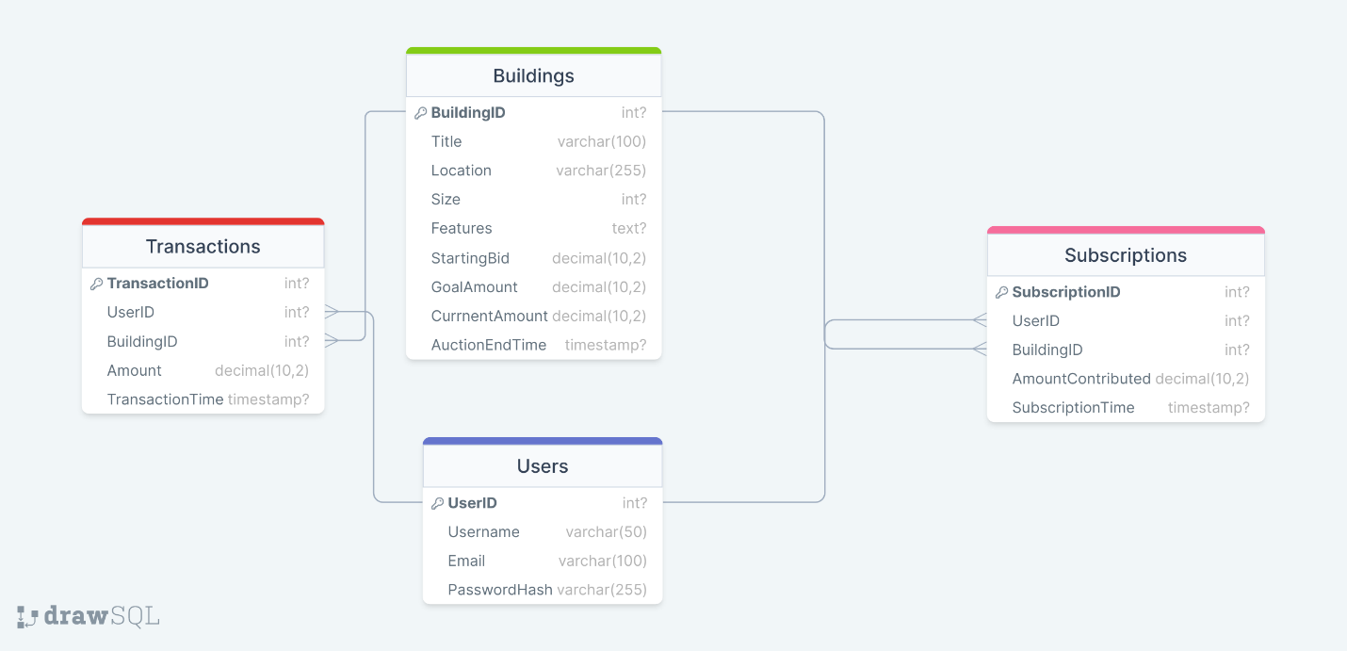

Use case diagram

